1.

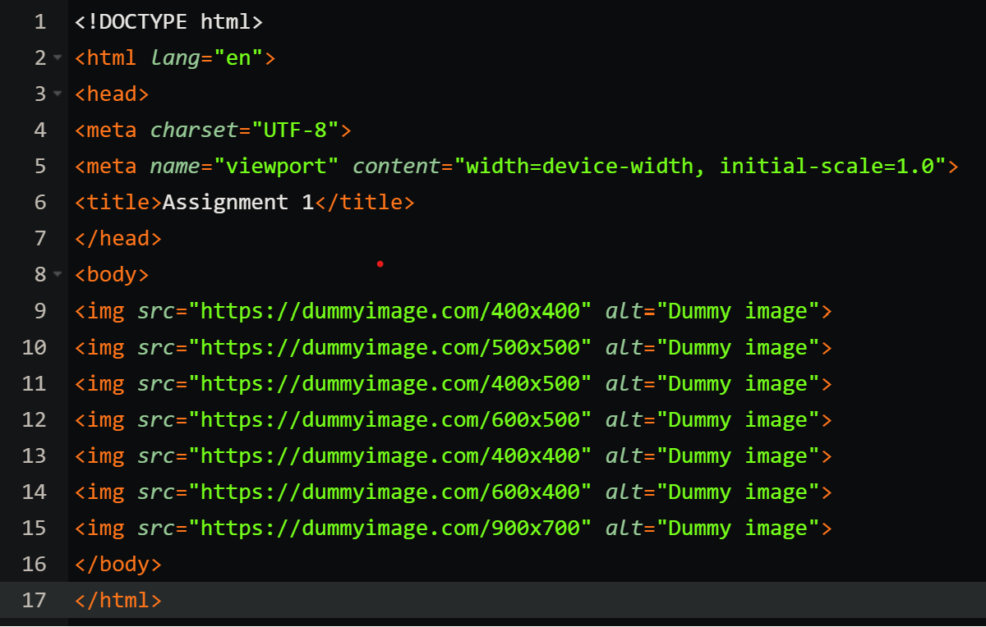

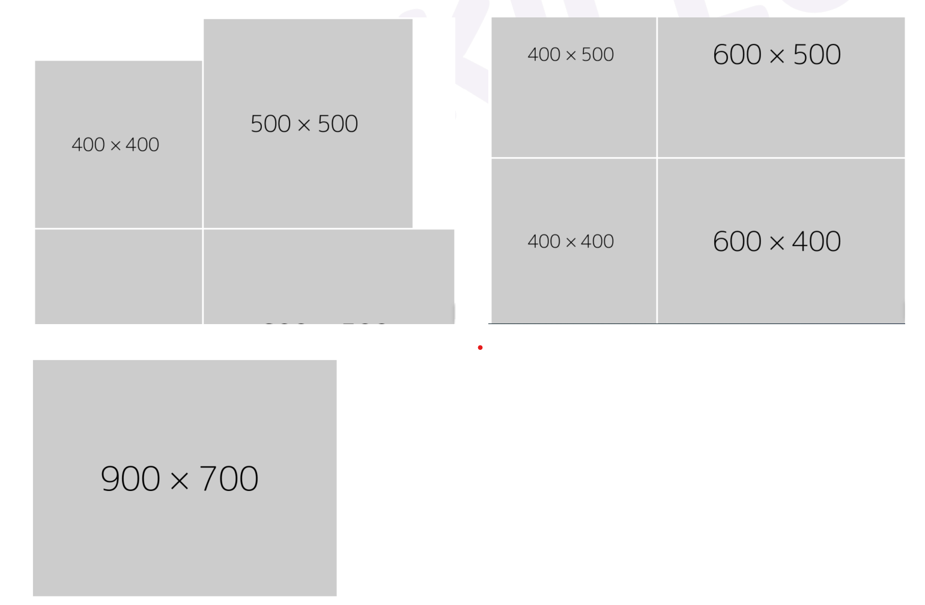

2.

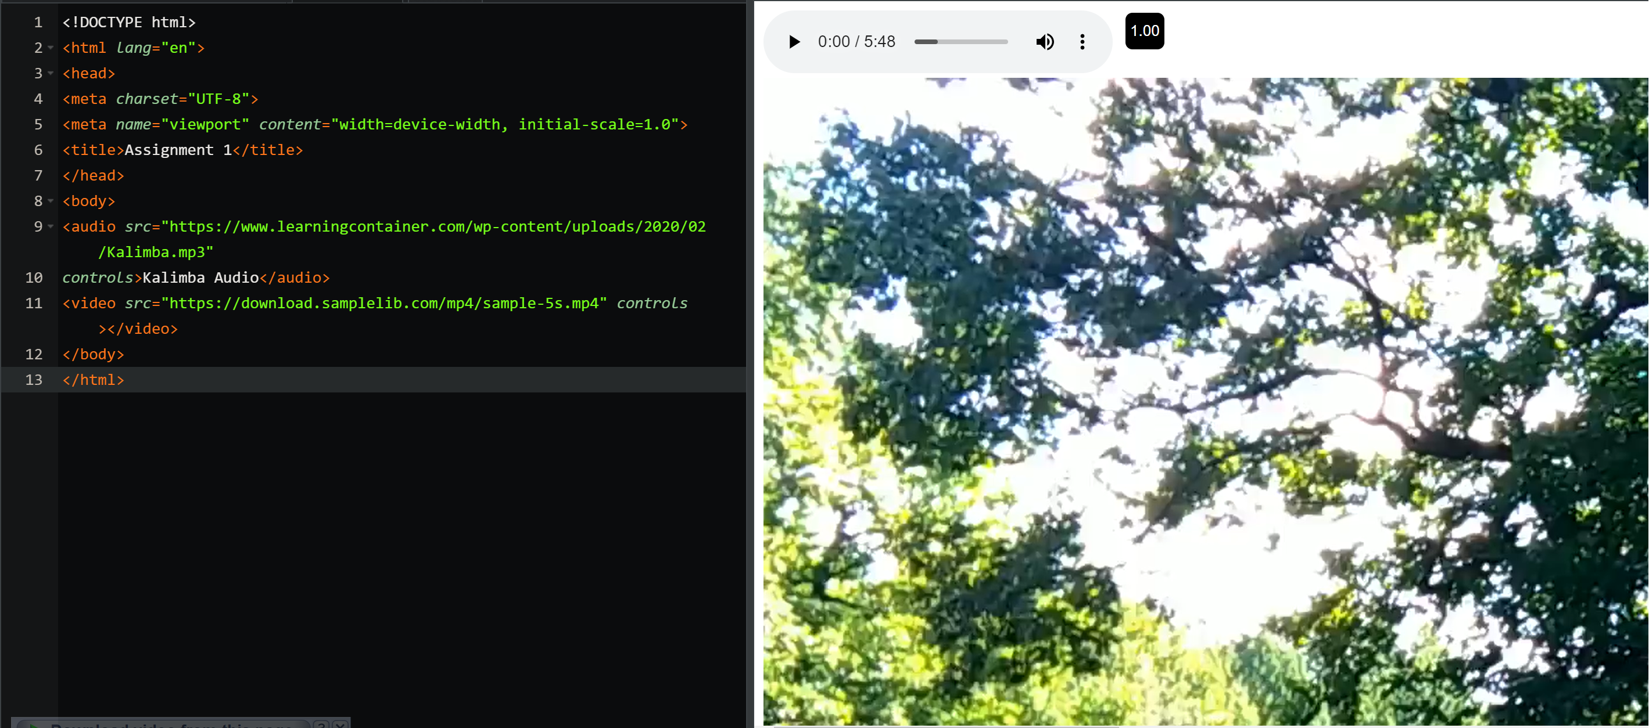

3.

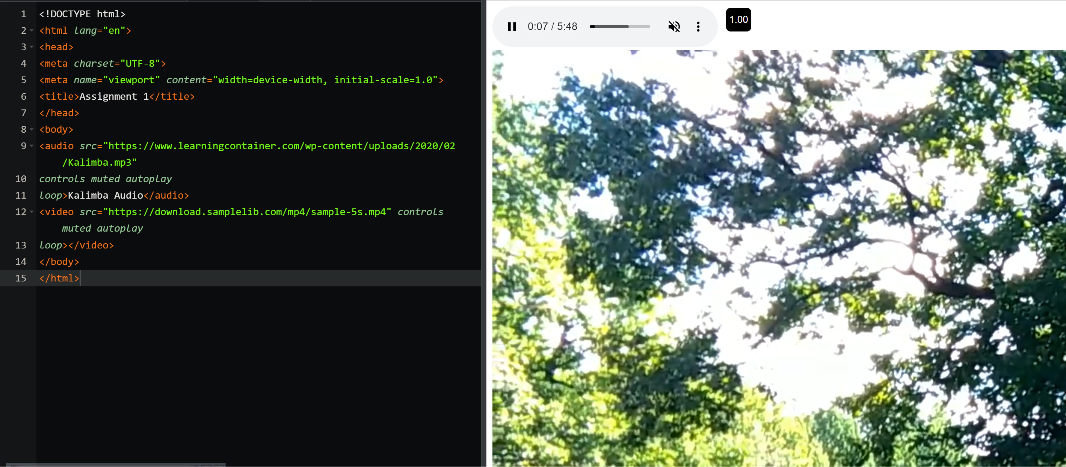

4. 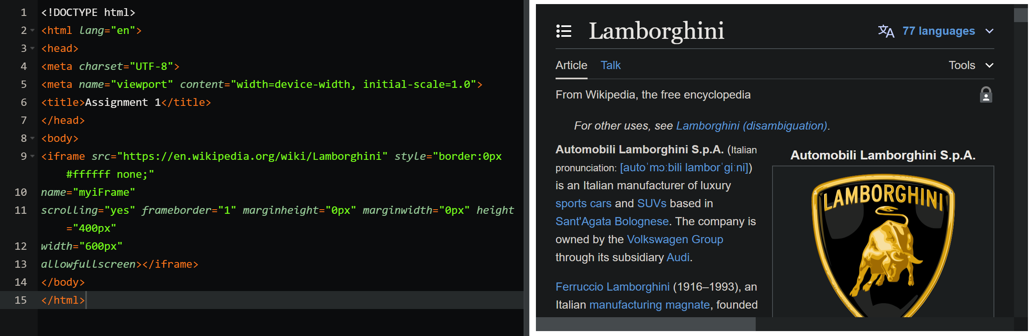

5.

<!DOCTYPE html>

<html lang="en">

<head>

<meta charset="UTF-8">

<meta name="viewport" content="width=device-width, initial-scale=1.0">

<title>Assignment 1</title>

</head>

<body>

<form>

<label for="firstName">First Name:

<input type="text" name="firstName" placeholder="Dracule" id="firstName" required

minlength=3 max=20 />

</label>

<br>

<label for="lastName">Last Name:

<input type="text" name="lastName" placeholder="Mihawk" id="lastName" required min=3

max=20 />

</label>

<br>

<label for="email">Email:

<input type="email" name="email" placeholder="iamLegend.com" id="email" required />

</label>

<br>

<label for="password">Password:

<input type="password" name="password" placeholder="\*\*\*\*\*\*\*\*" id="password" required

min=8 />

</label>

<br>

<label for="confirmPassword">Confirm Password:

<input type="password" name="confirmPassword" placeholder="\*\*\*\*\*\*\*\*"

id="confirmPassword" required />

</label>

<br>

<label for="age">Age:

<input type="number" name="age" placeholder="26" id="age" required min=0 max=150 />

</label>

<br>

<label for="">Gender:

<input type="radio" id="male" value="male" name="gender" checked />

<label for="male">Male</label>

<input type="radio" id="female" value="female" name="gender" />

<label for="female">Female</label>

<input type="radio" id="other" value="other" name="gender" />

<label for="other">Other</label>

</label>

<br>

<label for="terms">terms:

<input type="checkbox" id="terms" required /> I agree to terms and conditions

</label>

<br>

<button type="submit">Register</button>

</form>

</body>

</html>

